

American International University-Bangladesh (AIUB)
Department of Computer Science
Faculty of Science & Technology (FST)

PROJECT TITLE
ARTX(Online Art work buy , sell or auction platform)
Semester: Fall 25-26

Group:05 |  | Section: U
SL | Student Name | Student ID
1 | Asfaq Ahmed | 23-54102-3
2 | Adnan Faiz | 23-55400-3
3 | Prottoy Sutradhar | 24-56143-1
4 | Sabeha Aktar Emu | 22-49471-3
5 | MD Sajid Hasan Hridoy | 22-48624-3

Table of Contents

1. Project Proposal 03
1.1 Background to the Problem 03
1.2 Selection of Process Model 04
2. Software Requirements Specification (SRS) / PRD 07
2.1 Functional Requirements 07
2.2 Non-Functional Requirements 07
3. Software Design 26
3.1 System Deisgn 26
3.2 UI Deisgn using Figma 30
4. Git Workflow 36
5. Software Testing 37
6. Conclusion 44

1. PROJECT PROPOSAL

  - Background to the Problem
The art market is a vibrant and evolving space that includes the buying, selling, and showcasing of paintings, sculptures, digital art, and more. Despite its rich history and cultural value, the art world still faces deep-rooted challenges in its digital transformation journey.
Traditional art sales usually occur through galleries, exhibitions, or private dealers that can be difficult for new or independent artists to access. Although online art platforms have emerged, many fail to ensure transparency, fair pricing, authenticity verification, and equal visibility for all artists.
Some key challenges include:
1. Lack of transparency about the origin, pricing, and authenticity of artworks.
2. Limited trust between buyers and sellers, particularly for original pieces.
3. Poorly optimized platforms for professional art showcasing and secure transactions.
4. Absence of tools to help artists with pricing, marketing, and customer engagement.
This project aims to design and launch an effective digital platform that not only organizes the purchase and presentation of artwork, but also builds a more open, trustworthy, and profitable marketplace. By using modern digital tools, the platform will help streamline transactions, improve visibility for creators, and build confidence among collectors and buyers.
Root Causes:
The main problem is that independent artists find it hard to get attention, earn trust, and make regular sales online. These problems come from several connected reasons:
- An Oversaturated Market:
- Thousands of artists sell their work online, which makes it very hard for new artists to get noticed.
- Because there is so much artwork online, good-quality art often gets lost under cheap copies or popular trends chosen by algorithms
- Limited Marketing Experience:
- Many talented artists lack the marketing skills or financial resources to promote their work effectively.
- Social media algorithms rarely favor organic reach, which means that unless artists pay for visibility, they often remain unseen.
- Platform Constraints:
- Existing platforms like Etsy or Instagram aren't optimized for showcasing or valuing original artwork.
- These websites usually mix original, high-quality artworks with mass-produced items, which reduces their value and makes them harder to find.
- Trust Barriers with Buyers:
- Potential buyers often hesitate due to concerns about:
  - Authenticity of the piece.
  - The artist’s credibility.
  - Whether the transaction is secure.
  - The quality of what they’re receiving.
- Pricing Difficulties:
- Setting the right price is a constant struggle:
- Too high, and the work doesn’t sell.
- Too low, and the artist undercuts their own labor and skill.
- Without proper guidance, artists may either undervalue their work or fail to sell at all.
  - Selection of Process Model
For the development of ARTX, we have selected the Agile Software Development Model, specifically following the Scrum framework. Agile is an iterative and incremental development approach that emphasizes flexibility, collaboration, and continuous user feedback. Since ARTX is a user-centric and creative platform, its requirements may evolve based on artist and buyer interactions.
In each sprint cycle, functional components of the system—such as artist profiles, artwork uploading, secure payment processing, artwork verification, and search/filter features—will be developed and delivered incrementally. This allows early testing, user validation, and continuous improvement of the platform.
Agile development consists of short development cycles known as sprints, during which tasks are planned, developed, tested, and reviewed. This approach aligns well with ARTX’s dynamic nature, emerging technologies (such as AR preview and blockchain-based verification), and the need for frequent stakeholder feedback.
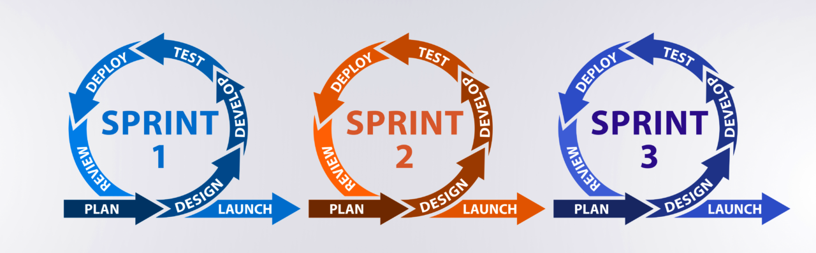
Fig: Agile software Development Model
Criteria-Based Evaluation of Agile Model for ARTX
Criteria | Agile Model Advantage for ARTX
Changing Requirements | Agile supports continuous adaptation as ARTX features may evolve based on artist and buyer feedback.
Small & Cross-functional Team | Scrum enables close collaboration between developers, designers, and testers within sprint cycles.
Rapid Prototyping & Feature Testing | Advanced features like AR preview and blockchain verification require iterative testing and refinement.
Frequent Feedback from Stakeholders | Artists and buyers can provide feedback during sprint reviews to improve usability and trust.
Risk Management | Agile helps identify and resolve risks related to payment security, authenticity, and performance early.
Delivery of MVP | Allows early release of core ARTX features for real-world user testing and validation.

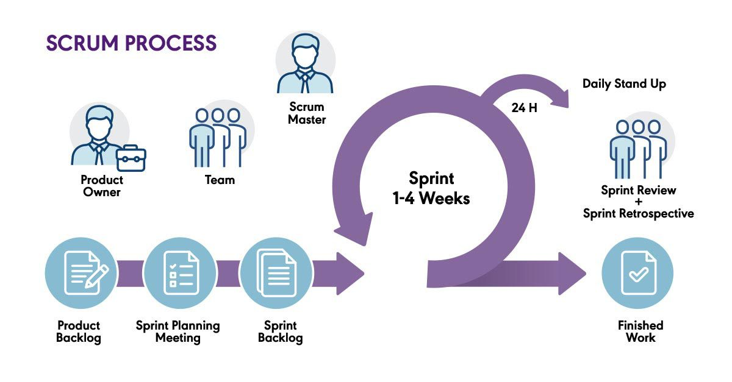
Fig: Scrum Process
Justification with Evidence
The selection of the Agile model for the ARTX project is justified based on the following considerations:
- Changing Requirements
As ARTX is a creative and user-driven platform, feature requirements such as pricing models, verification methods, and UI design may change. Agile supports continuous refinement without disrupting development.
- Team Size and Skills
The development team consists of members with cross-functional skills who can collaborate efficiently using Scrum practices such as daily stand-ups and sprint planning.
- Time Constraints
Scrum’s sprint-based approach allows the project to be divided into manageable tasks with clear timelines, ensuring steady progress and timely delivery.
- User Involvement
Agile enables frequent interaction with potential users (artists and buyers), allowing feedback to be incorporated regularly and improving overall system quality.
- Frequent Testing and Quality Assurance
The iterative nature of Agile ensures continuous testing, early bug detection, and faster system improvements.

2. PRODUCT REQUIREMENTS DOCUMENT (PRD)
Template Name |  | (ARTX)Online Art work buy, sell or auction platform
Goals & Objective |  | We all buy and sell art. The goal of this website is to provide a secure, easy, and trustworthy platform where artists can showcase their artwork and buyers can confidently purchase or bid on art.  From this website, artists/buyers can:  -Upload, showcase, and sell artwork in a simple and user-friendly way  -Browse, search, and purchase verified artwork securely  -Participate in auctions for unique or limited-edition art  -View transparent information such as artwork details, prices, and artist profiles  -Manage their own profile, update personal details, and track their activities  -Interact with the community through likes, comments, and follows  -Receive notifications about artwork status, purchases, bids, and interactions
Client Information
Product Type |  | Web Application
Domain |  | artx.com.bd
Access Layers |  | User, admin
Design Required |  | No
 |  |  |  | Functional Requirements
Phase | Item No | Specification [Role] | Screen Definition | User Story | Acceptance Criteria | Tags
Feature: 1
phase 1 | 1 | Signup [admin] [User][Buyer] | <Form>  <input=name>  <input=email>  <input=password>  <input=re-password>  <button=signup>  <link=signin> | As a new user, I want to register with my email so that I can access the platform. | - Email should be valid and not registered; otherwise show “email already used”.  - Password should be min 8 characters; otherwise show “password too short”.  - Confirm password should match password; otherwise show “password doesn’t match”.  - After success, store user data in database & redirect to dashboard.  -Confirmation email should be sent. | signup
phase 1 | 2 | Signin [User] | <Form>  <input=email>  <input=password>  <button=signin>  <link=signup>  <link=forgot password> | As a user, I want to securely log in so I can access my account and dashboard. | - Email and password should match database.  - If mismatch, should show “email or password incorrect”.  - Successful login should redirect to dashboard.  - Remember-me should store session for 7 days. | signin
phase 1 | 3 | Forgot password[User] | <Form>  <input=email>  <button=send code>  <input=code>  <input=password>  <input=confirm Password>  <button=submit> | As a user who forgot his/her password, I want to reset it so I can regain access. | -If email not found, should show “email not registered”.  -System should send 6-digit code to email.  -Code should match database record.  -New password should be min 8 characters.  -Password and confirm password should match.  -After success, should show “password changed”. | forgot_password
Phase 1 | 4 | Logout [User] | <button=logout> | As a user, I want to log out so my account remains secure. | -User session should end successfully  -User should be redirected to sign-in screen | logout
Feature: 2
phase 2 | 5 | Upload Artwork[Artist] | <Form>  <input=image>  <input=title maxlength=60>  <select=category>  <input=price type=number>  <button=upload>  </Form> | As an artist, I want to upload my artwork with details so buyers can view and purchase it. | -Image file should be required; otherwise show “image required”.  -Title should be required (max 60 chars).  -Category should be selected.  -Price should be a positive number.  -System should store artwork in database and flag as “pending verification”. | artwork, upload
Phase 2 | 6 | Edit Artwork [Artist] | <artwork-form>  <input=title>  <select=category>  <input=price>  <button=save> | As an artist, I want to edit my artwork details so I can update pricing or information. | -Artist should be able to update own artwork  -Changes should be saved successfully  -Artwork should remain verified unless admin re-review is required | artwork, edit
Phase 2 | 7 | Delete Artwork [Artist] | <artwork-details>  <button=delete>  <confirm-dialog> | As an artist, I want to delete my artwork so it is no longer available. | -Artist should be able to delete own artwork  -Artwork should be removed from buyer listings  -Confirmation should be required before deletion | artwork, delete
Phase 2 | 8 | Artwork Details View [User] | <artwork-image>  <details>  <artist-info> | As a user, I want to view full artwork details before deciding to purchase. | -Artwork details load correctly  -Verified badge is visible  -Artist information is displayed | artwork, view
phase 2 | 9 | Artwork Verification[Admin] | <List>  <artwork-details>  <button=approve>  <button=reject>  </List>  <Reject>  <textarea=reason>  </Reject> | As an admin, I want to verify artwork submissions so the platform maintains authenticity. | -Admin should view all pending submissions.  -Approving should set artwork status to “verified”.  -Rejecting should require a reason message.  -User should receive email notification on decision. | admin, verification
Feature: 3
phase 3 | 10 | Browse & Search[Buyer] | <input=search>  <select=category>  <input=price-filter>  <artwork-list verified-only> | As a buyer, I want to browse and filter artworks so I can find items that match my interests. | -Search should return matching titles/descriptions.  -Filters should update result list instantly.  -Only verified artworks should appear. | browsing, search
Phase 3 | 11 | Artwork Details View [User] | <artwork-image>  <details>  <artist-info> | As a user, I want to view full artwork details before deciding to purchase. | -Artwork should load correctly  -Verified badge should be visible  -Artist information should be displayed | artwork, view
Feature: 4
phase 4 | 12 | Artwork Purchase[Buyer] | <artwork-details>  <price>  <button=buy>  <button=confirm-payment> | As a buyer, I want to purchase artwork securely so I can receive the item. | -System should validate artwork availability.  -Payment should be processed securely.  -After success, status should become “sold”.  -Purchase receipt should be emailed. | purchase, payment
phase 4 | 13 | Order History[Buyer, Artist] | <order-list>  <artwork-title>  <buyer/artist>  <price>  <status> | As a user, I want to view my transaction history so I can track my purchases or sales. | -List should show order date, artwork name, status, amount.  -Should display successful and refunded orders.  -Data should match database records. | orders, history
Phase 4 | 14 | Wallet Balance View [User] | <balance-display>  <transaction-summary> | As a user, I want to view my wallet balance so I can manage purchases. | -Current balance should be displayed  -Balance updates after should be transactions | wallet, balance
Phase 4 | 15 | Add Funds to Wallet [User] | <input=amount>  <button=add-funds> | As a user, I want to add funds to my wallet so I can buy artwork. | -Amount should be added successfully  -Wallet balance should be updated  -Transaction should be recorded | wallet, transaction
Feature: 4
phase 5 | 16 | Engagement[user] | <artwork-view>  <button=like>  <button=comment>  <button=share> | As a user, I want to like or comment on artworks so I can interact with the community. | -User should be logged in to like/comment.  -Likes should be update count instantly.  -Comments should appear in chronological order.  -Inappropriate content should be flagged automatically. | social, interaction
Phase 5 | 17 | Report Artwork [User] | <button=report>  <textarea=reason> | As a user, I want to report artwork so inappropriate content can be reviewed. | -Report should be submitted successfully  -Admin should receive the report | report, moderation
Feature: 5
phase 6 | 18 | Notifications[user] | <table>  Name  Email  Phone  Date of Birth  gender  user type  edit | As a user, I want to receive notifications on actions that matter to me. | -Should Notify buyer when purchase succeeds.  -Should Notify artist when artwork is approved or sold.  -Should Notify users when someone comments or follows.  -Notifications should be marked as read after user views them. | notifications
Phase 6 | 19 | Notification Preferences [User] | <notification-settings>  <toggle=email>  <toggle=in-app> | As a user, I want to control notification settings so I receive relevant updates. | -User should be able to enable or disable notifications  -Preferences should be saved | notifications, settings
Feature: 10
phase 7 | 20 | Admin Dashboard [Admin] | <stats-cards>  <pending-artworks>  <user-summary> | As an admin, I want a dashboard overview so I can manage the platform. | -Pending items should be visible  -Summary statistics should be shown | admin, dashboard
 |  |  |  | Non-Functional Requirements
Phase | Item No | Specification [Role] | Screen Definition | User Story | Acceptance Criteria | Tags
Feature: 1
phase 1 | 1 | Page Load Time | <all-screens> | As a user, I want screens to load quickly so I can use the system efficiently. | -Pages load should be within 3 seconds under normal conditions | performance, usability
phase 1 | 2 | Search Response | <search-results> | As a buyer, I want fast search results so I can find artwork quickly. | -Search results load should be within 2 seconds | signin
Feature: 2
phase 2 | 3 | Concurrent Users | <system> | As a platform owner, I want the system to handle many users at once. | -System should support at least 10,000 concurrent users | scalability, system
Phase 2 | 4 | Data Growth | <database> | As an admin, I want the system to scale as artwork increases. | -System should handle large artwork records without slowdown | scalability, database
Feature: 3
phase 3 | 5 | Password Protection | <signup>  <signin> | As a user, I want my password to be securely stored. | -Passwords should be encrypted and not stored in plain text | artwork, upload
Phase 3 | 6 | Secure Transactions | <payment> | As a buyer, I want my transactions to be secure. | -All transactions should use secure connections (HTTPS) | security, transaction
Phase 3 | 7 | Role-Based Access | <all-screens> | As an admin, I want restricted access based on user roles. | Users should only access role-specific features | security, access-control
Feature: 4
phase 4 | 8 | System Availability | <system> | As a user, I want the platform to be available when needed. | -System uptime should be at least 99.5% | reliability, availability
phase 4 | 9 | Error Recovery | <system> | As an admin, I want the system to recover from failures. | -System recover should be within 1 hour of failure | reliability, recovery
Phase 4 | 10 | Logging & Audit | <transactions> | As an admin, I want transaction logs for auditing. | -All transactions should be logged and traceable | logging, audit
Feature: 5
phase 5 | 11 | Responsive Design | <all-screens> | As a user, I want to use the system on any device. | -UI should adapts mobile and desktop screens | usability, responsive
phase 5 | 12 | Error Messages | <form-screens> | As a user, I want clear error messages when something goes wrong. | -Errors should be readable and understandable | usability, validation
Phase 5 | 13 | Navigation Consistency | <navigation> | As a user, I want consistent navigation across screens. | -Navigation layout should remain consistent | usability, UI
Feature:6
phase 6 | 14 | Modular Design | <system> | As a developer, I want modular code for easy maintenance. | -System should follow modular architecture | maintainability, architecture
Phase 6 | 15 | Updates | <system> | As an admin, I want updates without downtime. | -Minor updates should not affect system availability | maintainability, deployment
Feature: 7
phase 7 | 16 | Browser Support | <all-screens> | As a user, I want the system to work on my browser. | -Should work on latest Chrome, Firefox, Edge | compatibility, browser
Phase 7 | 17 | Image Formats | <upload-artwork> | As an artist, I want to upload common image formats. | -JPG and PNG formats should be supported | compatibility, media
Feature: 8
Phase 8 | 18 | Data Integrity | <orders> | As a user, I want accurate order data. | -Order history should match transaction records | data, integrity
phase 8 | 19 | User Data Protection | <profile> | As a user, I want my personal data protected. | -User data should not be exposed to unauthorized users | privacy, security
Phase 8 | 20 | Data Retention | <system> | As an admin, I want data retained as per policy. | -System should follow defined data retention rules | compliance, policy

3. SOFTWARE DESIGN
3.1 System Design:
3.1.1 Use Case Diagram
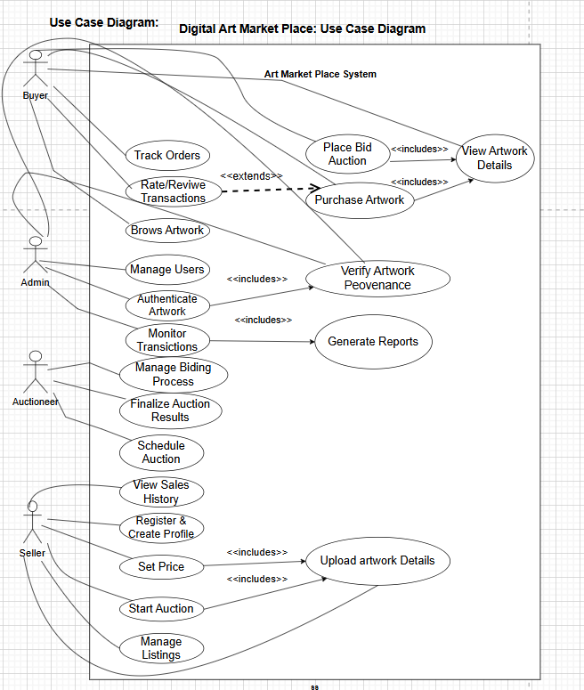

3.1.2 Class Diagram
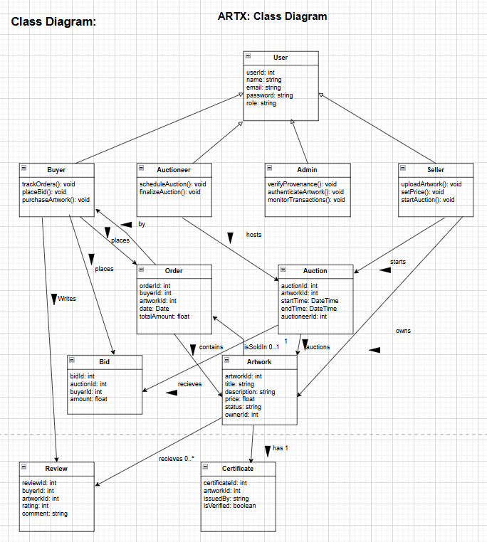

3.1.3 Activity diagram
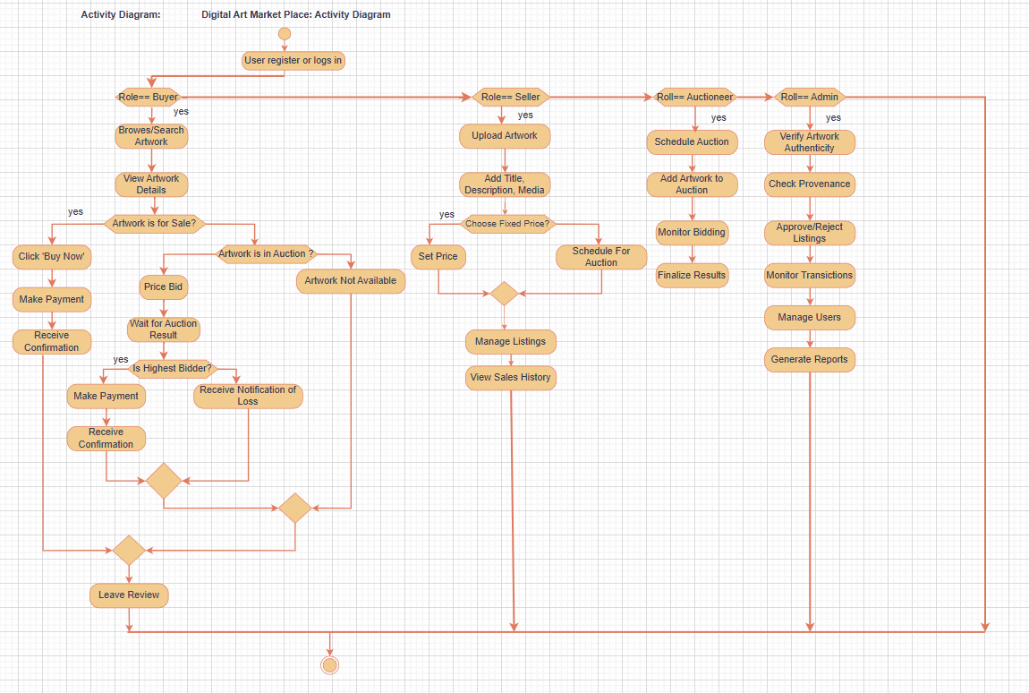

3.1.4 Sequence diagram
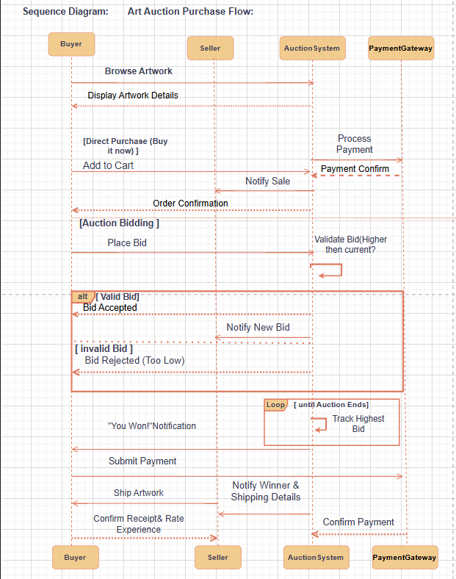

UI / Wireframe Design using Figma
1.
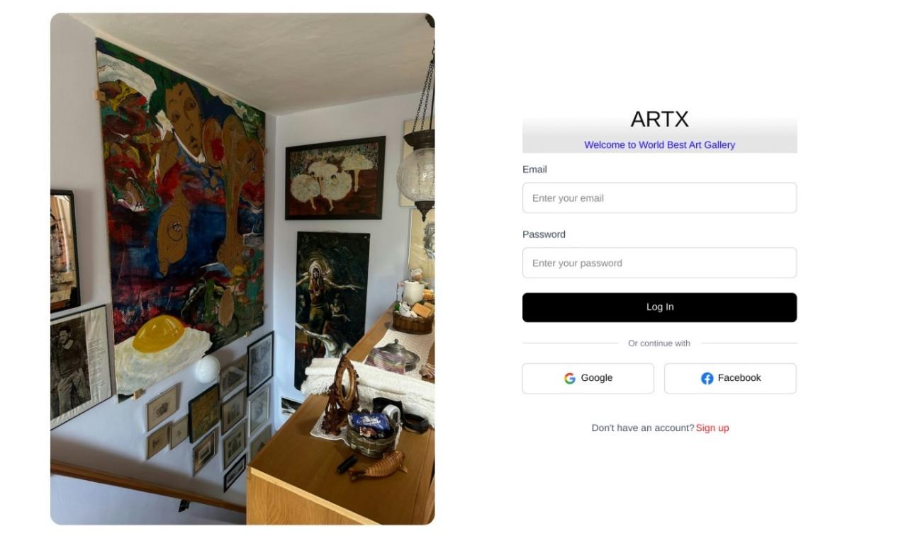
2.
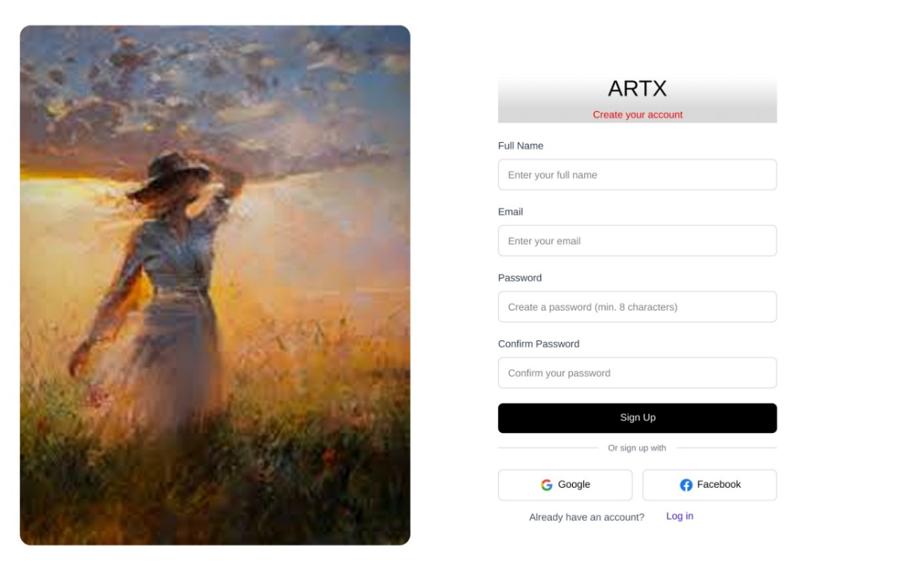
3.
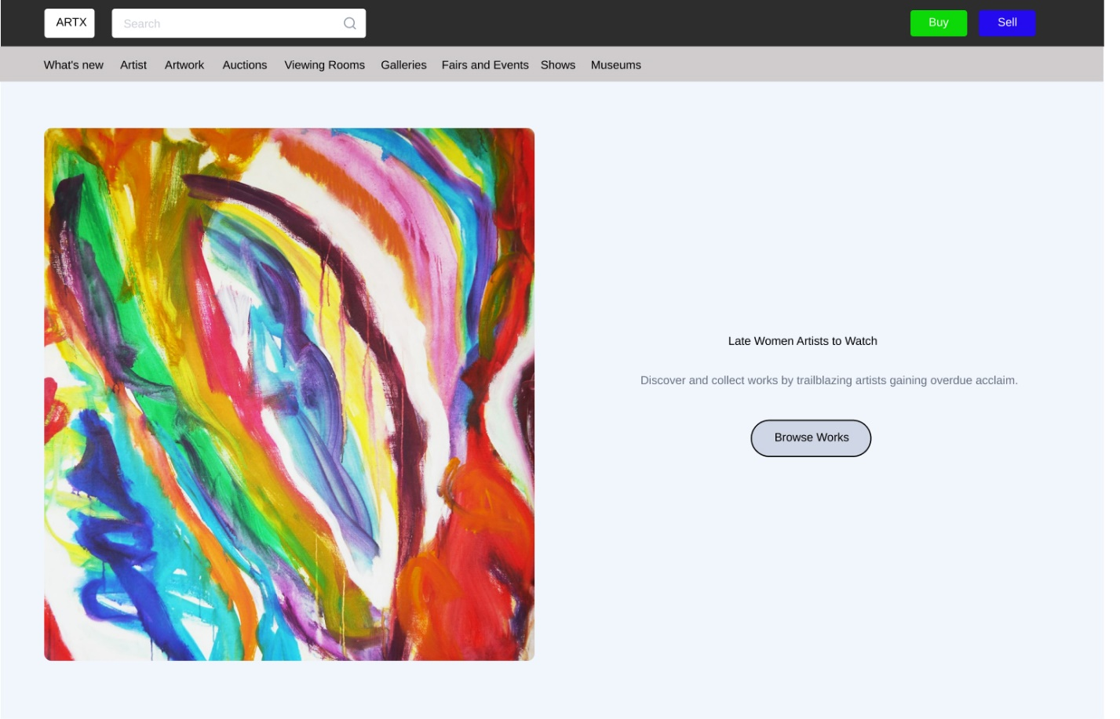
4.
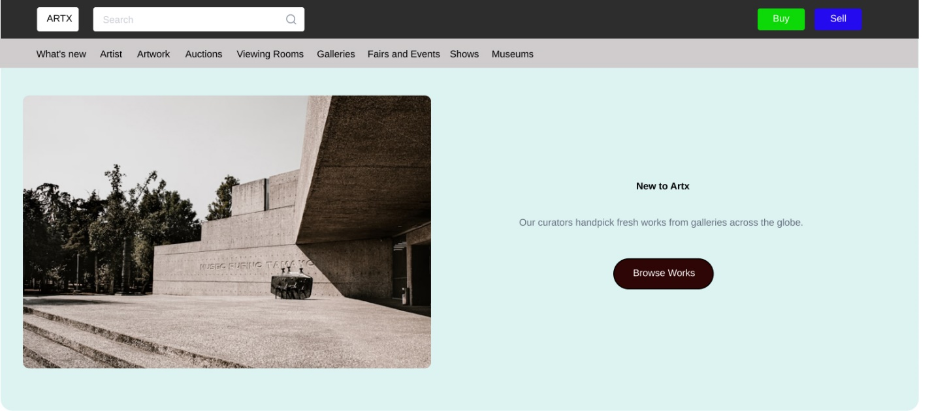

5.
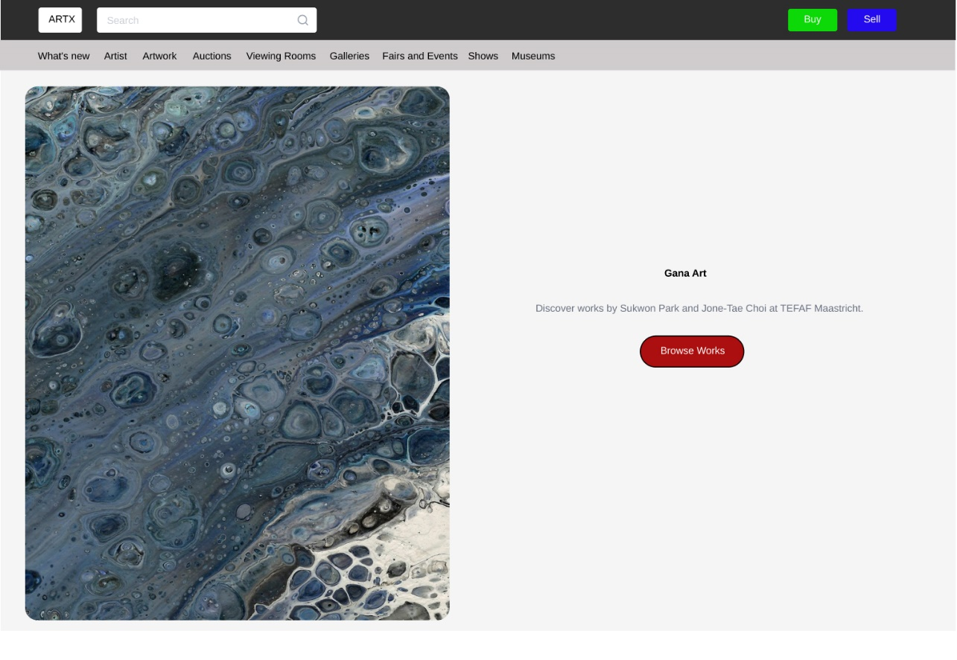
6.
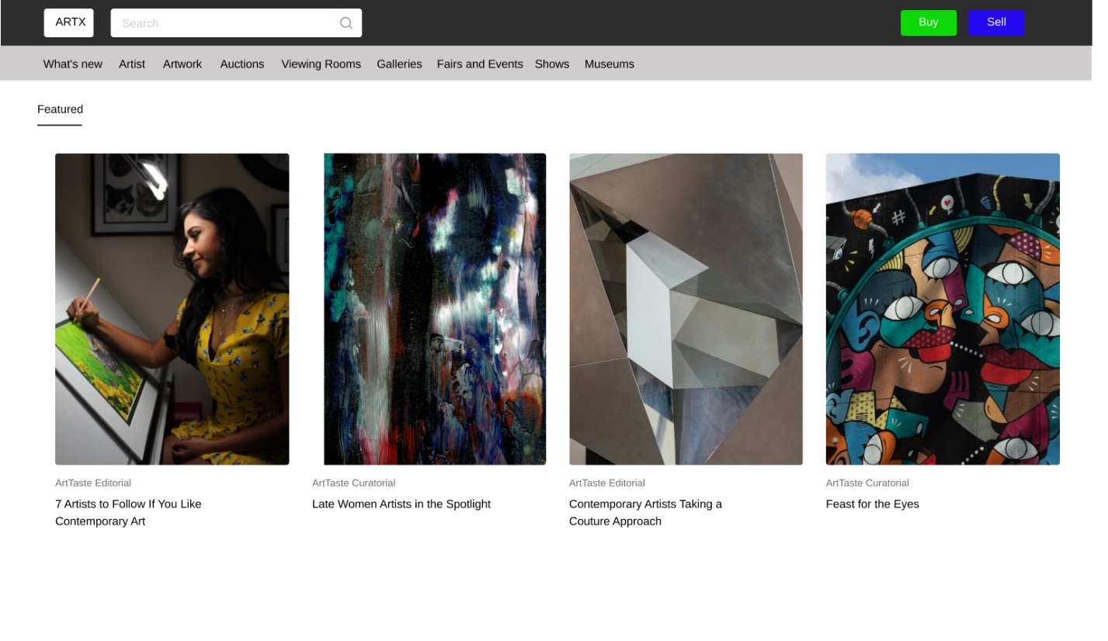
7.
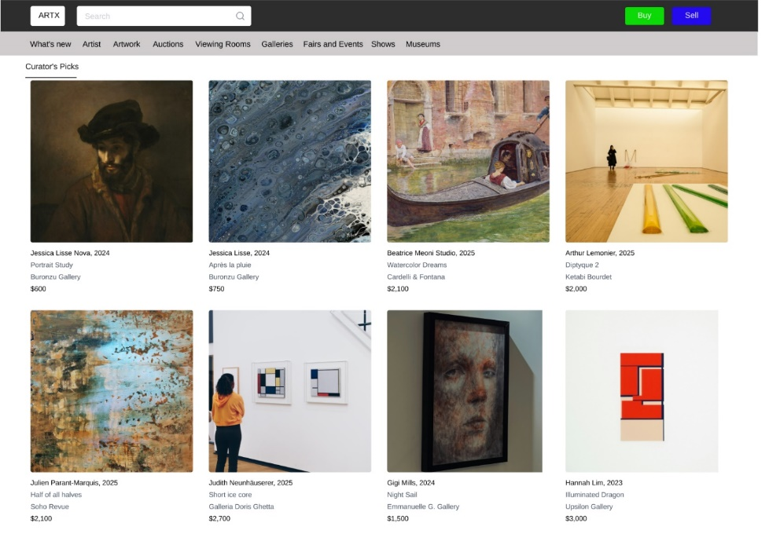
8.
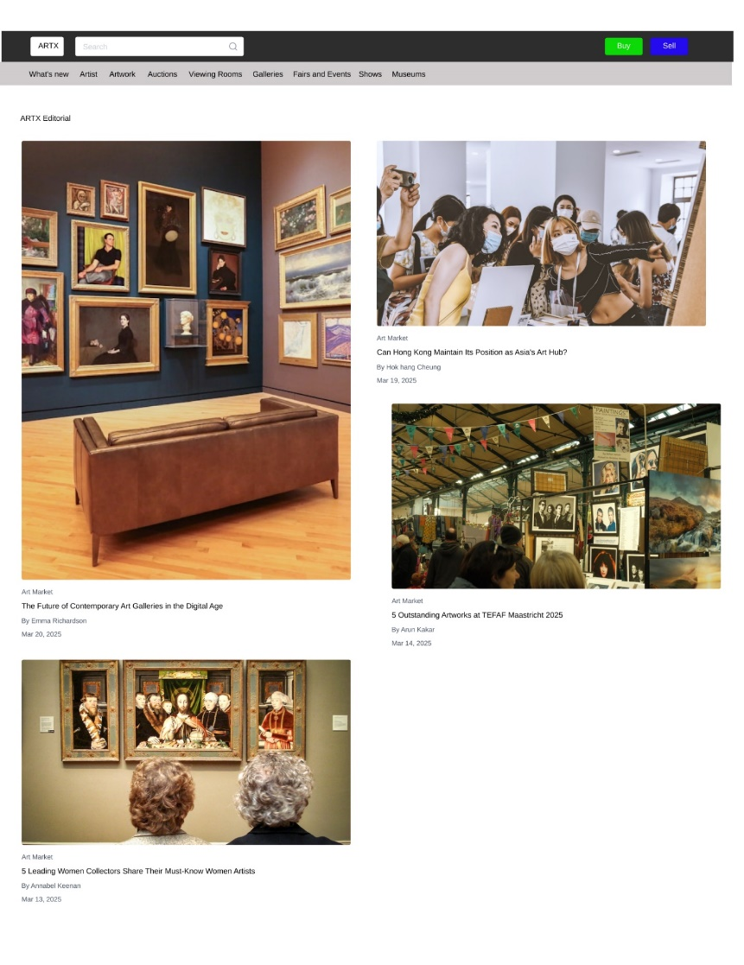
9.
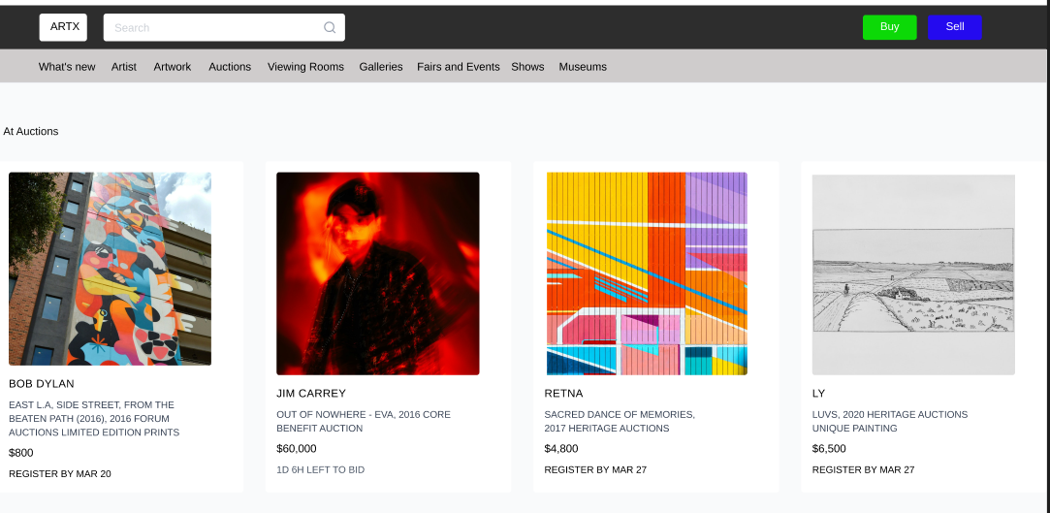
10.
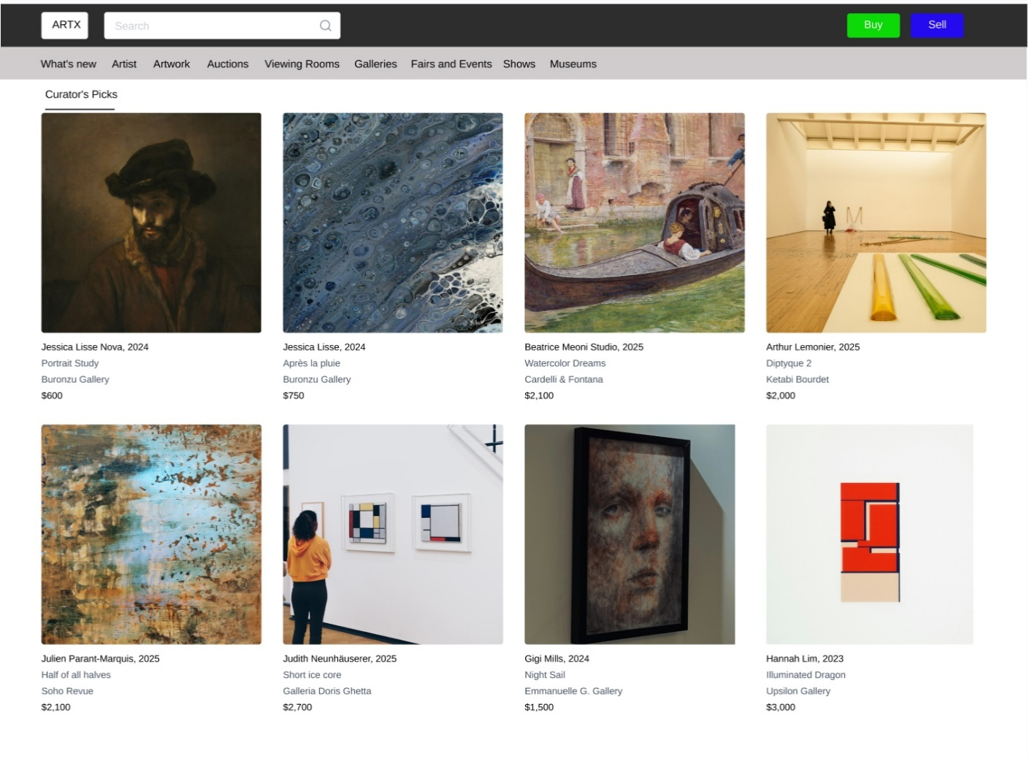
11.
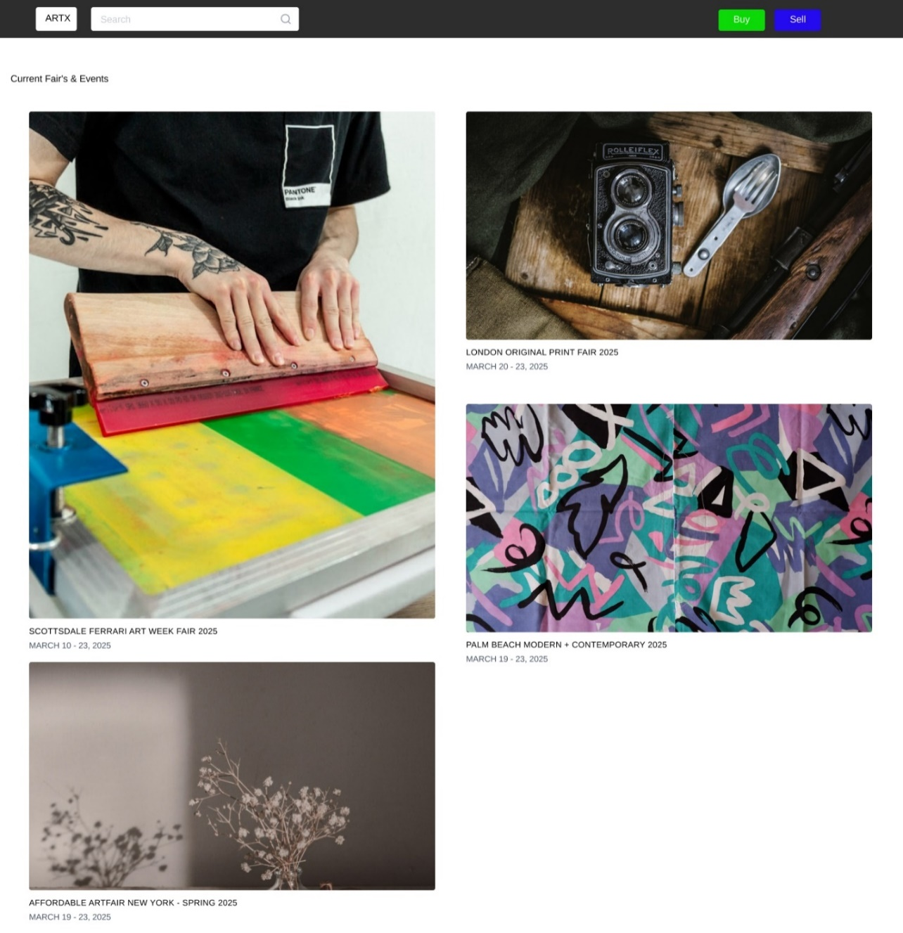
12.
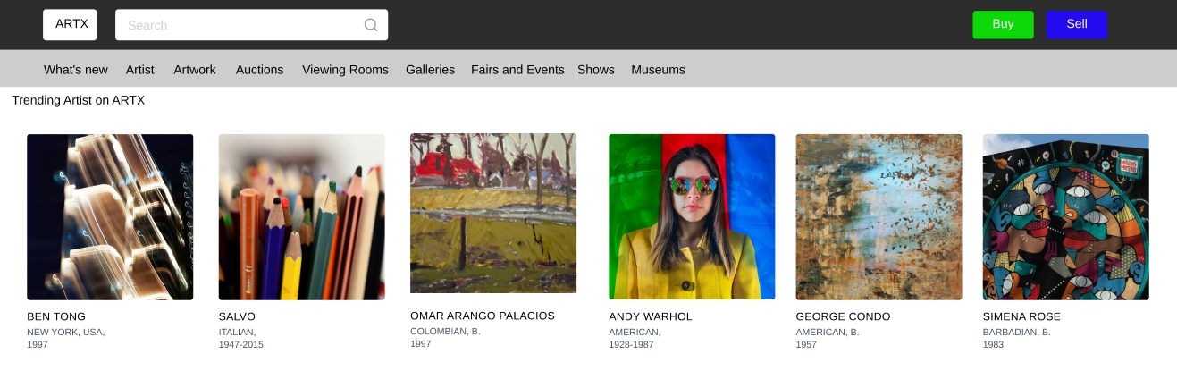

4. GIT WORKFLOW
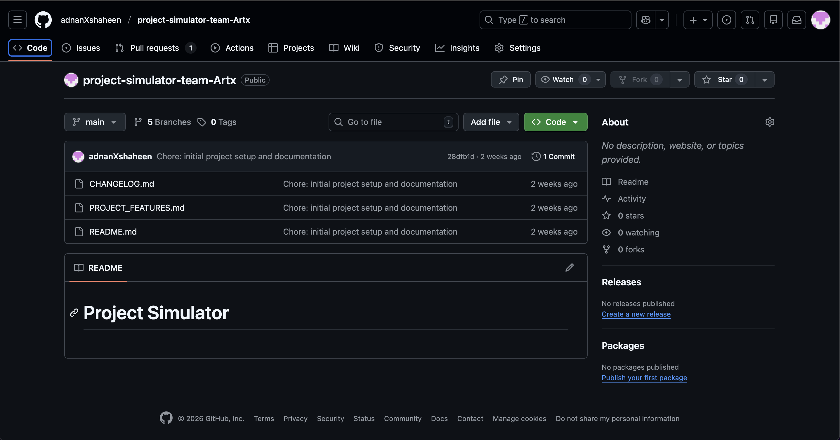
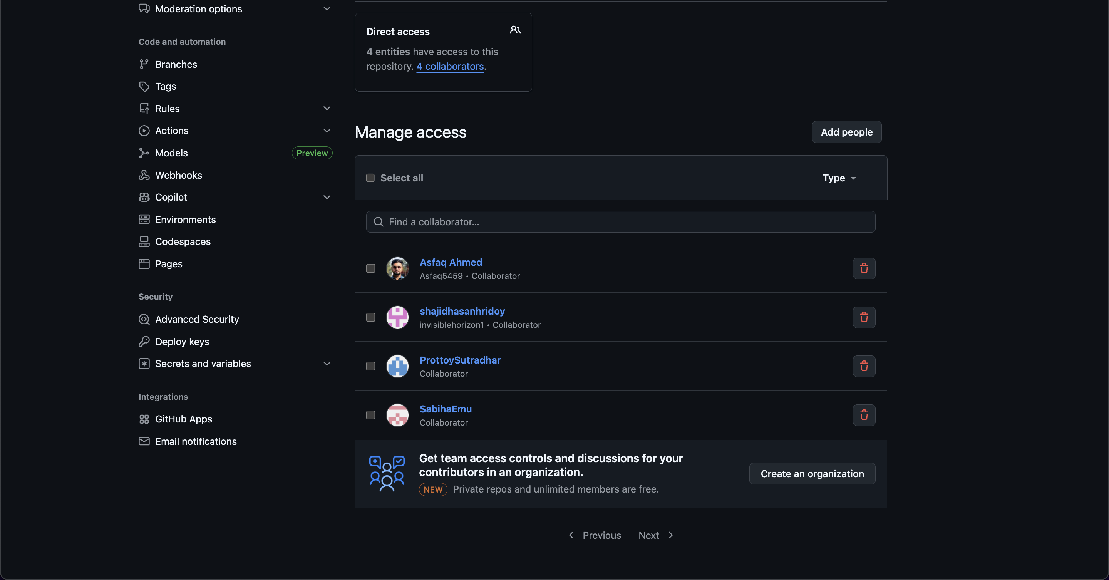

SOFTWARE TESTING
Project Name: ARTX – Online Artwork Buy, Sell & Auction Platform | Test Designed by: Asfaq
Test Case ID: ARTX_BK_01 | Test Designed date: 21/12/2025
Test Priority (Low, Medium, High): High | Test Executed by:
Module Name: Account Registration | Test Execution date:
Test Steps | Test Data | Actual Results
1. Go to website  2. Click Sign Up  3. Enter valid details (email, password, full name)  4. Submit form | 1. Valid email  2. Strong password

Project Name: ARTX – Online Artwork Buy, Sell & Auction Platform | Test Designed by: Asfaq
Test Case ID: ARTX_BK_02 | Test Designed date: 21/12/2025
Test Priority (Low, Medium, High): High | Test Executed by:
Module Name: Account Login | Test Execution date:
Test Steps | Test Data | Actual Results
1. Go to website  2. Click Login  3. Enter credentials  4. Submit form | Valid approved email & password

Project Name: ARTX – Online Artwork Buy, Sell & Auction Platform | Test Designed by: Asfaq Ahmed
Test Case ID: ARTX_BK_03 | Test Designed date: 21/12/2025
Test Priority (Low, Medium, High): High | Test Executed by:
Module Name: Artwork Upload | Test Execution date:
Test Steps | Test Data | Actual Results
1. Login  2. Go to Upload section  3. Enter details  4. Upload image  5. Submit | Title, description, medium, size, price, JPG file

Project Name: ARTX – Online Artwork Buy, Sell & Auction Platform | Test Designed by: Adnan Faiz
Test Case ID: ARTX_BK_04 | Test Designed date: 22/12/2025
Test Priority (Low, Medium, High): High | Test Executed by:
Module Name: Blockchain Authenticity Certificate | Test Execution date:
Test Steps | Test Data | Actual Results
1. Login  2. View uploaded artwork  3. Click Generate Certificate  4. Wait  5. Scan QR code | Uploaded artwork

Project Name: ARTX – Online Artwork Buy, Sell & Auction Platform | Test Designed by: Adnan Faiz
Test Case ID: ARTX_BK_05 | Test Designed date: 22/12/2025
Test Priority (Low, Medium, High): High | Test Executed by:
Module Name: Smart Search & Filters | Test Execution date:
Test Steps | Test Data | Actual Results
1. Go to search bar  2. Enter keyword  3. View results | painting price<500

Project Name: ARTX – Online Artwork Buy, Sell & Auction Platform | Test Designed by: Adnan Faiz
Test Case ID: ARTX_BK_06 | Test Designed date: 22/12/2025
Test Priority (Low, Medium, High): High | Test Executed by:
Module Name: Admin User Management | Test Execution date:
Test Steps | Test Data | Actual Results
1. Login  2. Go to User Management  3. Search pending artist  4. Click Approve | Pending artist account

Project Name: ARTX – Online Artwork Buy, Sell & Auction Platform |  |  |  | Test designed by:
Test Case ID: ARTX_FR_07 |  |  |  | Test Designed date:
Test Priority (Low, Medium, High): High |  |  |  | Test Executed by:
Module Name: Buy Artwork |  |  |  | Test Execution date:
Test Title: Purchase an artwork
Description: This test case is designed to verify the expected behavior of the system under normal operating conditions.
Precondition (If any): The user must be registered and authorized to access the system.
Test Steps | Test Data | Expected Results | Actual Results |  | Status (Pass/Fail)
1. Select an artwork  2. Complete payment | Payment Method: Card  Amount: 5000 | The system should confirm the purchase and generate an order record.

Project Name: ARTX – Online Artwork Buy, Sell & Auction Platform |  |  |  | Test designed by:
Test Case ID: ARTX_FR_08 |  |  |  | Test Designed date:
Test Priority (Low, Medium, High): High |  |  |  | Test Executed by:
Module Name: Auction Creation |  |  |  | Test Execution date:
Test Title: Create an auction
Description: This test case is designed to verify the expected behavior of the system under normal operating conditions.
Precondition (If any): The user must be registered and authorized to access the system.
Test Steps | Test Data | Expected Results | Actual Results |  | Status (Pass/Fail)
1. Select artwork  2. Set auction details  3. Submit | Start Price: 3000  Duration: 3 Days | The system should create the auction and make it available for bidding.

Project Name: ARTX – Online Artwork Buy, Sell & Auction Platform |  |  |  | Test designed by:
Test Case ID: ARTX_FR_09 |  |  |  | Test Designed date:
Test Priority (Low, Medium, High): High |  |  |  | Test Executed by:
Module Name: Place Bid |  |  |  | Test Execution date:
Test Title: Place a higher bid
Description: This test case is designed to verify the expected behavior of the system under normal operating conditions.
Precondition (If any): The user must be registered and authorized to access the system.
Test Steps | Test Data | Expected Results | Actual Results |  | Status (Pass/Fail)
1. Enter bid amount  2. Submit bid | Bid Amount: 3500 | The system should accept the bid and update the current highest bid.

Project Name: ARTX – Online Artwork Buy, Sell & Auction Platform |  |  |  | Test designed by:
Test Case ID: ARTX_FR_10 |  |  |  | Test Designed date:
Test Priority (Low, Medium, High): High |  |  |  | Test Executed by:
Module Name: Bid Validation |  |  |  | Test Execution date:
Test Title: Attempt lower bid
Description: This test case is designed to verify the expected behavior of the system under normal operating conditions.
Precondition (If any): The user must be registered and authorized to access the system.
Test Steps | Test Data | Expected Results | Actual Results |  | Status (Pass/Fail)
1. Enter lower bid amount | Bid Amount: 2000 | The system should reject the bid and display an appropriate message.

Project Name: ARTX – Online Artwork Buy, Sell & Auction Platform |  |  |  | Test designed by:
Test Case ID: ARTX_FR_11 |  |  |  | Test Designed date:
Test Priority (Low, Medium, High): High |  |  |  | Test Executed by:
Module Name: Auction Result |  |  |  | Test Execution date:
Test Title: Declare auction winner
Description: This test case is designed to verify the expected behavior of the system under normal operating conditions.
Precondition (If any): The user must be registered and authorized to access the system.
Test Steps | Test Data | Expected Results | Actual Results |  | Status (Pass/Fail)
1. End auction | Highest Bid | The system should identify the highest bidder and declare the winner.

Project Name: ARTX – Online Artwork Buy, Sell & Auction Platform |  |  |  | Test Designed by:
Test Case ID: ARTX_AD_12 |  |  |  | Test Designed date:
Test Priority (Low, Medium, High): High |  |  |  | Test Executed by:
Module Name: User Management |  |  |  | Test Execution date:
Test Title: Enable user account
Description: This test case is designed to verify the expected behavior of the system under normal operating conditions.
Precondition (If any): The user must be registered and authorized to access the system.
Test Steps | Test Data | Expected Results | Actual Results |  | Status (Pass/Fail)
1. Login as admin  2. Enable selected user | Username: hridoy | The user should be able to log in after account activation.

Project Name: ARTX – Online Artwork Buy, Sell & Auction Platform |  |  |  | Test designed by:
Test Case ID: ARTX_AD_13 |  |  |  | Test Designed date:
Test Priority (Low, Medium, High): High |  |  |  | Test Executed by:
Module Name: User Management |  |  |  | Test Execution date:
Test Title: Disable user account
Description: This test case is designed to verify the expected behavior of the system under normal operating conditions.
Precondition (If any): The user must be registered and authorized to access the system.
Test Steps | Test Data | Expected Results | Actual Results |  | Status (Pass/Fail)
1. Login as admin  2. Disable selected user | Username: hridoy | The system should block the user from logging in.

Project Name: ARTX – Online Artwork Buy, Sell & Auction Platform |  |  |  | Test designed by:
Test Case ID: ARTX_FR_14 |  |  |  | Test Designed date:
Test Priority (Low, Medium, High): High |  |  |  | Test Executed by:
Module Name: Notification |  |  |  | Test Execution date:
Test Title: Send auction notification
Description: This test case is designed to verify the expected behavior of the system under normal operating conditions.
Precondition (If any): The user must be registered and authorized to access the system.
Test Steps | Test Data | Expected Results | Actual Results |  | Status (Pass/Fail)
1. Complete auction process | Auction Notification | The system should send notifications to relevant users.

Project Name: ARTX – Online Artwork Buy, Sell & Auction Platform |  |  |  | Test designed by:
Test Case ID: ARTX_FR_15 |  |  |  | Test Designed date:
Test Priority (Low, Medium, High): High |  |  |  | Test Executed by:
Module Name: Logout |  |  |  | Test Execution date:
Test Title: Log out from the system
Description: This test case is designed to verify the expected behavior of the system under normal operating conditions.
Precondition (If any): The user must be registered and authorized to access the system.
Test Steps | Test Data | Expected Results | Actual Results |  | Status (Pass/Fail)
1. Click Logout | N/A | The system should end the session and redirect to the login page.

6. CONCLUSION
ARTX represents a meaningful step toward transforming the online art market for independent artists and buyers alike. By addressing core challenges like lack of visibility, trust issues, authenticity concerns, pricing difficulties, and limited marketing support, this platform creates a more transparent, secure, and artist-friendly ecosystem. Features such as personalized portfolios, smart search and filters, blockchain-backed authenticity certificates, AR previews, fair pricing guidance, secure payments, community engagement tools, and marketing templates empower artists to showcase their original work confidently while helping buyers discover and purchase art with greater trust and convenience.
Developed through careful requirement analysis, thoughtful system design, and effective project management, ARTX not only meets technical and functional goals but also considers societal impact by promoting cultural diversity, fair trade, and creativity. The collaborative effort of the team ensured timely contribution toward a sustainable and user-centric solution.
Ultimately, ARTX has the potential to bridge the gap between talented independent creators and art enthusiasts, fostering a vibrant digital marketplace that values originality, builds lasting connections, and supports the growth of the art community in a fair and accessible way.
Figma: https://www.figma.com/design/MhIGCgvSoFNZJAFwcphx36/ARTX-by-Asfaq?node-id=0-1&p=f&m=draw

